Packet Loss

❌ What Is Packet Loss in Networking?
# Source: AI Source: Provided by: [Data Path: Persons Table -> ID Column: 1, Name_En Column: Motasem Essam] -> From: [ChatGPT] on [12/15/2025]
Packet loss occurs when one or more data packets fail to reach their destination across a network. It’s a key indicator of network problems and can disrupt communication, especially for real-time services like video calls, gaming, or VoIP.

📦 Belongs to:
# Source: AI Source: Provided by: [Data Path: Persons Table -> ID Column: 1, Name_En Column: Motasem Essam] -> From: [ChatGPT] on [12/15/2025]
✅ Network Performance Metrics
Along with Latency, Throughput, Bandwidth, and Jitter

🧠 Definition:
# Source: AI Source: Provided by: [Data Path: Persons Table -> ID Column: 1, Name_En Column: Motasem Essam] -> From: [ChatGPT] on [12/15/2025]
Packet loss is the percentage of data packets that are sent but not received successfully.

📉 Causes of Packet Loss
# Source: AI Source: Provided by: [Data Path: Persons Table -> ID Column: 1, Name_En Column: Motasem Essam] -> From: [ChatGPT] on [12/15/2025]
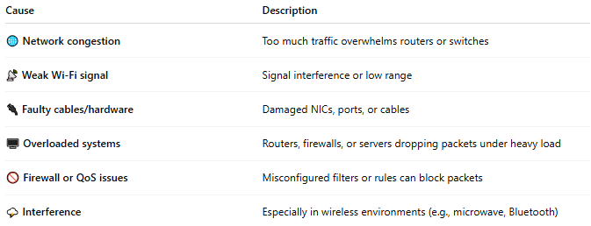
Cause | Description
🌐 Network congestion | Too much traffic overwhelms routers or switches
📡 Weak Wi-Fi signal | Signal interference or low range
🔌 Faulty cables/hardware | Damaged NICs, ports, or cables
🖥️ Overloaded systems | Routers, firewalls, or servers dropping packets under heavy load
🚫 Firewall or QoS issues | Misconfigured filters or rules can block packets
🌩️ Interference | Especially in wireless environments (e.g., microwave, Bluetooth)

🛠 How to Detect Packet Loss
# Source: AI Source: Provided by: [Data Path: Persons Table -> ID Column: 1, Name_En Column: Motasem Essam] -> From: [ChatGPT] on [12/15/2025]
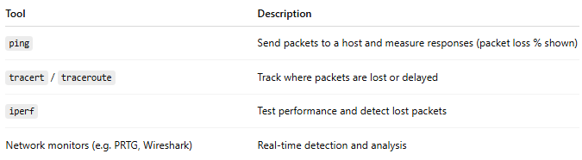
Tool | Description
ping | Send packets to a host and measure responses (packet loss % shown)
tracert / traceroute | Track where packets are lost or delayed
iperf | Test performance and detect lost packets
Network monitors (e.g. PRTG, Wireshark) | Real-time detection and analysis

📊 Impact of Packet Loss
# Source: AI Source: Provided by: [Data Path: Persons Table -> ID Column: 1, Name_En Column: Motasem Essam] -> From: [ChatGPT] on [12/15/2025]
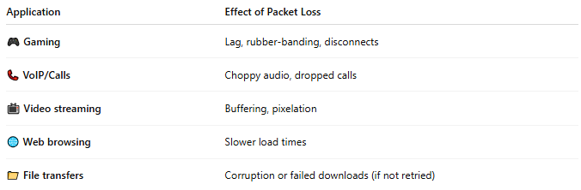
Application | Effect of Packet Loss
🎮 Gaming | Lag, rubber-banding, disconnects
📞 VoIP/Calls | Choppy audio, dropped calls
📺 Video streaming | Buffering, pixelation
🌐 Web browsing | Slower load times
📁 File transfers | Corruption or failed downloads (if not retried)

📏 Acceptable Packet Loss?
# Source: AI Source: Provided by: [Data Path: Persons Table -> ID Column: 1, Name_En Column: Motasem Essam] -> From: [ChatGPT] on [12/15/2025]
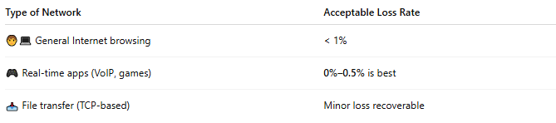
Type of Network | Acceptable Loss Rate
🧑‍💻 General Internet browsing | < 1%
🎮 Real-time apps (VoIP, games) | 0%–0.5% is best
📥 File transfer (TCP-based) | Minor loss recoverable

✅ How to Reduce Packet Loss
# Source: AI Source: Provided by: [Data Path: Persons Table -> ID Column: 1, Name_En Column: Motasem Essam] -> From: [ChatGPT] on [12/15/2025]
- 📶 Use wired connections instead of Wi-Fi when possible
- 🔄 Restart or upgrade routers/switches
- 🛡 Check for overloaded firewalls or VPNs
- 🧰 Replace damaged cables or ports
- 📡 Reduce interference (change Wi-Fi channel, move devices)
- 🚦 Use Quality of Service (QoS) to prioritize critical traffic

📌 Summary
# Source: AI Source: Provided by: [Data Path: Persons Table -> ID Column: 1, Name_En Column: Motasem Essam] -> From: [ChatGPT] on [12/15/2025]

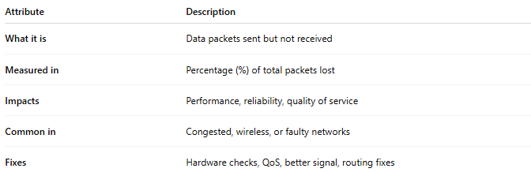
Attribute | Description
What it is | Data packets sent but not received
Measured in | Percentage (%) of total packets lost
Impacts | Performance, reliability, quality of service
Common in | Congested, wireless, or faulty networks
Fixes | Hardware checks, QoS, better signal, routing fixes

